To: Craig McKinney, Director, Palm Coast Economic Development
Cc: Eunice Choi, Regional Director, FSBDC at UCF, Hal Thayer, Associate Director, FSBDC at UCF
From: Michael Oppenheim, Area Manager, Florida SBDC at UCF – Palm Coast
Date: October 23, 2025
Re: Quarterly Performance Report – Q4-2025 (07/01/2025-09/30/2025)

Overview of the Florida SBDC at UCF

The Florida SBDC at UCF serves an eight-county area, including Brevard, Flagler, Lake, Sumter, Orange, Osceola, Seminole, and Volusia Counties.

The mission of the Florida SBDC at UCF is to provide high-quality management advice and comprehensive business training through the collaboration of higher education and economic development organizations, contributing to Central Florida's economic growth.

The Florida SBDC at UCF – Palm Coast Center was created to provide no cost, expert, one-on-one consulting and training to prospective, emerging, and established entrepreneurs in Palm Coast. By providing the necessary tools to area entrepreneurs, our business consultants help develop business plans, marketing plans, supply market and industry research, assist with loan proposals, guide the development of strategic plans, and provide a range of other services.

Consulting Summary for Quarter Ending September 30, 2025:
 | Total Quarter 4 | Total  Fiscal Year
Distinct Clients* | 20 | 77
Consulting Sessions | 64 | 252
Total Hours (Consultation and Preparation) | 179 | 663

*Total of distinct Palm Coast clients during the quarter. Clients may have multiple sessions during that time.

Activities

The Florida SBDC at UCF – Palm Coast supports pre-venture and start-ups (less than three years in business) through individualized counseling, market research services, financial statement review and analysis, business planning, and other services. Our assistance is tailored to each client's situation and experience.

For established companies, we have an even broader range of support services available. In addition to our core service offerings, we work with these clients to find new customers, new markets, grow their skills and employees' skills, improve operating results, and enhance their companies' sustainability for the long term.

Outreach Activities

The following outreach efforts in the community have occurred or have been scheduled:

- Working with local banks and attending one bank’s staff meeting to better explain the values and benefits of the SBDC
- Identifying Chamber meeting to give presentation on the benefits of SBDC
- Leveraging existing customers for referrals
- Palm Coast Success Story Published and picked up by Observer

Quarterly Training Events

The following training events were available to Palm Coast business owners during this quarter:

- AI 101 for Small Business Owners
- Business Plan Writing Made Easier
- How to Start Your Business
- How to Unlock the Power of AI in Google Ads
- Marketing Basics
- Government Contracting: Overview

Economic Impact for Quarter 4
The Florida SBDC at UCF assisted Palm Coast small business owners with creating two new businesses, creating two new jobs and $50,000 in capital formation.

Total Economic Impact Reported for Fiscal Year 24-25

 | Capital Formation | New Business Starts | New  Jobs Created | Jobs  Retained | Sales  Increase
Quarter 1 | $10,626 | 6 | 8
Annual Survey |  |  |  | 8 | $328,449
Quarter 2 | $1,178,225 | 7 | 20
Quarter 3 | $111,500 | 4 | 6
Quarter 4 | $50,000 | 2 | 2
TOTAL | $1,350,351 | 19 | 36 | 8 | $328,449

New Businesses Created Industry Classification:
- Therapy Counseling
- Food Manufacturing Consulting

Consulting Requests
Palm Coast small business owners have requested assistance in the following areas during the quarter: government contracting, capital access assistance, market/growth assistance and start-up assistance. Capital access accounted for 44.8% of consulting hours, while Start Up Assistance and Market Growth accounted for 25.7% and 22.4% respectively. A breakdown of these areas by consulting hours is displayed below.

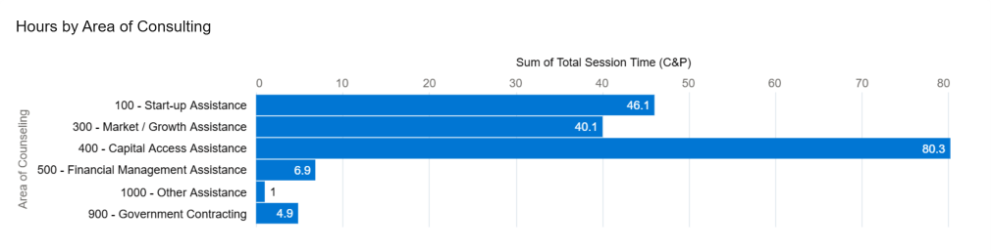

Additional Metrics
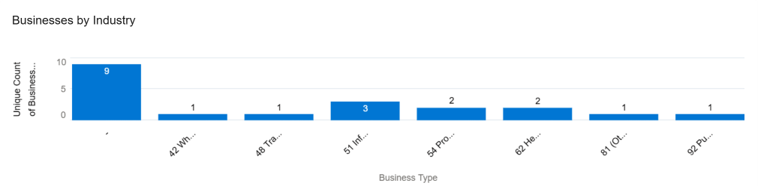
Pre-Venture

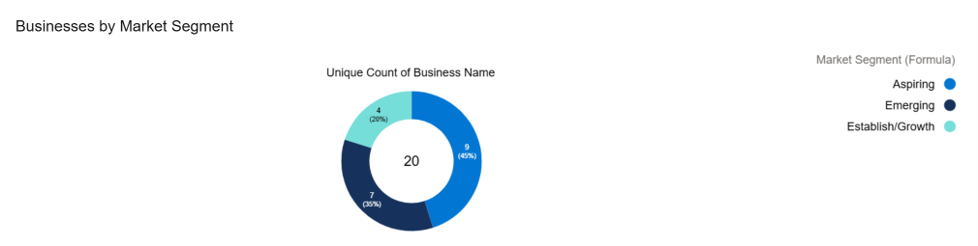

Fiscal 2024/2025 (10/01/24 – 9/30/25) Summary

Business Served: 77
Consulting Hours: 663
Consulting Sessions: 252
Capital Formation: $1,350,351
New Jobs Created: 36
Jobs Retained: 08
New Businesses Created: 19
Number of Training Webinars/Seminars Available to Clients: 51

