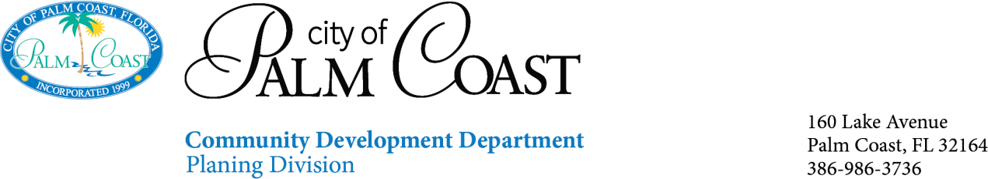

Mobile Food Dispensary Accessary Use APPLICATION
property owners only to approve locations for mobile food dispensary vendors

Property Owner Name
Address |  |  |  |  |  | Building |  |  |  |  | Suite
City |  |  |  |  |  | State |  |  |  |  | Zip
Description of
Business (Use)
Number of Locations on Site
Applicant Name
Phone |  |  |  | Email
Mailing Address
City |  |  |  |  |  |  | State |  |  |  |  | Zip
Submittal Requirements:
- Application properly completed, signed and notarized
- Authorization Letter properly signed and notarized (if required)
- Corporate Identity form properly signed and notarized
- Site Plan/ Survey on 8 ½ x 11 include location(s)of Mobile Food Vehicle Pad

Mobile Food Dispensing Vehicles Accessory Use requires the applicant to show on a site plan or survey the proposed layout of mobile food dispensary vendor pad including site pad area dimension, setbacks, and provide number of parking spaces reduced from approved current parking site plan. In accordance with ordinance 2026-xx Mobile Food Dispensary are prohibited from the following seating area, tables, tents, or canopies are allowed on site. Also, amplified noise or music is NOT permitted at these sites. Mobile food dispensary must have a registered and licensed vehicle from department of agriculture.

Next steps:
- You will be contacted via email when the permit is ready.
- The permit may be paid for online and inspection scheduled online at WWW.PALMCOASTGOV.COM/EPLANREVIEW.
- A certificate of Use will be issued following the approved final inspection.
- Certificate of use must be given to Local Business Tax.

