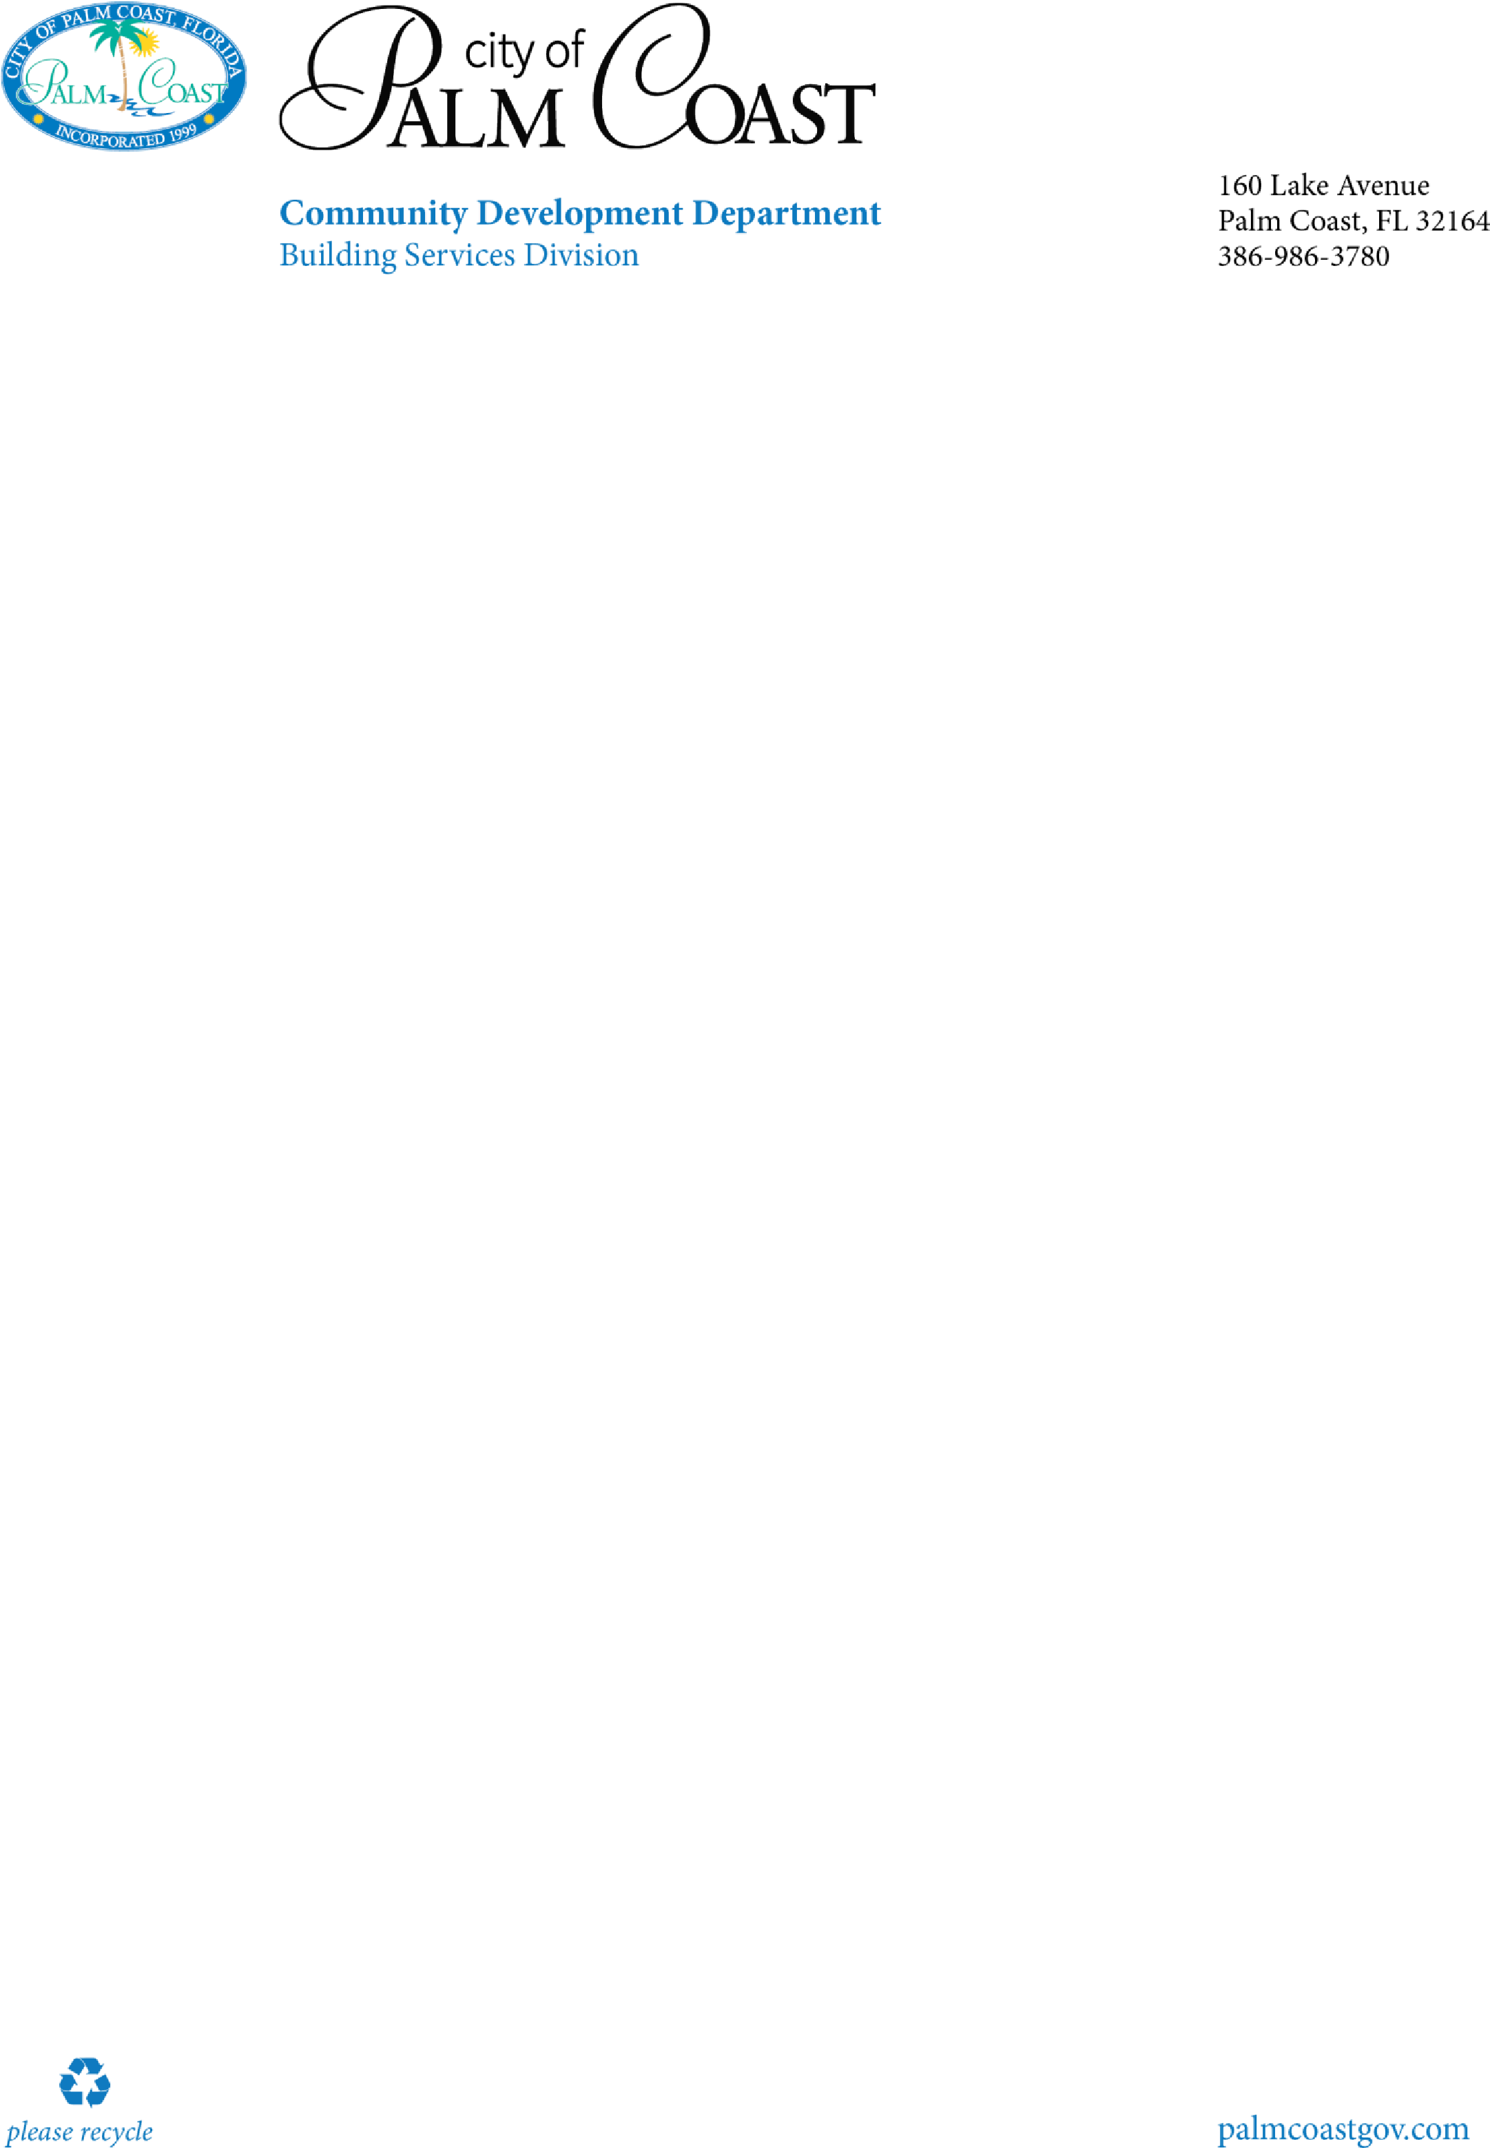

1.

Permit ap

plication

-

please include the Florida Product Approval # in the job

description(example

-

Shingle reroof

-

FL # 40599)

2.

Roofing Workshee

t

3.

Proof of property ownership

-

recorded deed or property appraisers office printout

4.

Notice of commencement

*(*

*certified copy*

*)*

this is required for any improvements to your

property greater than $2,500.The notice of commencement

is to be filled out, and

recorded with the Flagler County Clerk

’

s office in Bunnell.

It is not required at the time of

permit issuance, but will be required prior to any inspections.

Roofing

Commercial

Checklist

Visit our website for additional information

[https://www.palmcoastgov.com/government/building/contra](https://www.palmcoastgov.com/government/building/contractor-permitting)

[c](https://www.palmcoastgov.com/government/building/contractor-permitting)

[r](https://www.palmcoastgov.com/government/building/contractor-permitting)

[to](https://www.palmcoastgov.com/government/building/contractor-permitting)

[-](https://www.palmcoastgov.com/government/building/contractor-permitting)

[g](https://www.palmcoastgov.com/government/building/contractor-permitting)

[permittin](https://www.palmcoastgov.com/government/building/contractor-permitting)