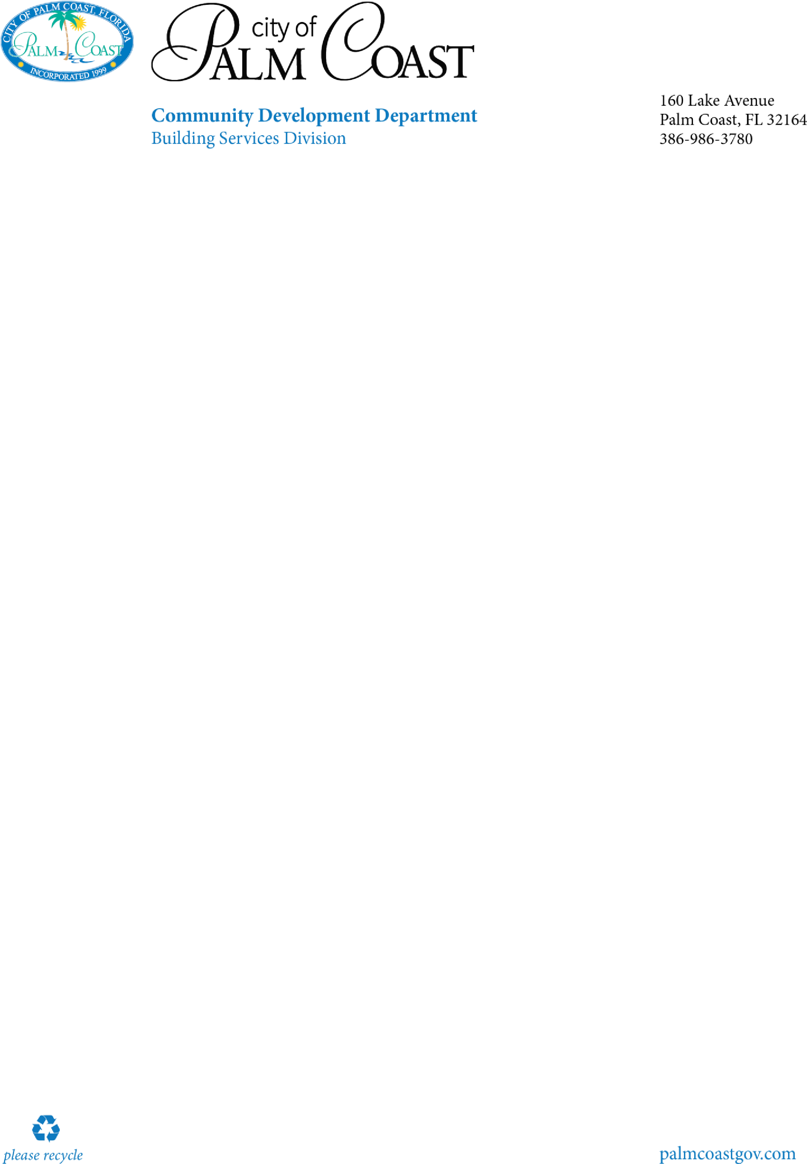

1.

Permit Application (must specify if shutters are motorized)

2.

Product Approval Sheet

a.

Detail/installation sheets are to be at the job s

ite for the inspection (do not submit to the office)

3.

Building Footprint Outline

a.

Reasonably drawn sketch outline of the home's footprint with windows and door locations shown,

b.

A keyed reference at each window to receive a shutter that matches up with a shut

ter type.

i.

example

1.

Window #1.

Roll Down Shutters T&C 6.8 SL Opening

38

x

63

2.

Window # 2

Roll Down Shutters T&C 6.8 SL Opening

28

x

52

4.

If shutters are motorized

a.

Submit electrical Pan

b.

Include electric subconractor

5.

Proof of property ownership

-

reco

rded deed or property appraisers office printout

6.

Construction lien law affidavit

-

for any job greater than $2,500 (contractor issued permits only)

7.

Owner/Builder Disclosure Statement (owner builders only)

8.

Notice

of commencement

*(*

*certified copy*

*)*

this is required for any improvements to your property greater than

$2,500.The notice of commencement is to be filled out, and recorded with the Flagler County Clerk’s office in

Bunnell. IT is not required at the time of

permit issuance, but will be required prior to any inspections.

Hurrican

e

Shutters

Checklist

Visit our website for additional information

[https://www.palmcoastgov.com/government/building/contra](https://www.palmcoastgov.com/government/building/contractor-permitting)

[c](https://www.palmcoastgov.com/government/building/contractor-permitting)

[to](https://www.palmcoastgov.com/government/building/contractor-permitting)

[r](https://www.palmcoastgov.com/government/building/contractor-permitting)

[-](https://www.palmcoastgov.com/government/building/contractor-permitting)

[permittin](https://www.palmcoastgov.com/government/building/contractor-permitting)

[g](https://www.palmcoastgov.com/government/building/contractor-permitting)