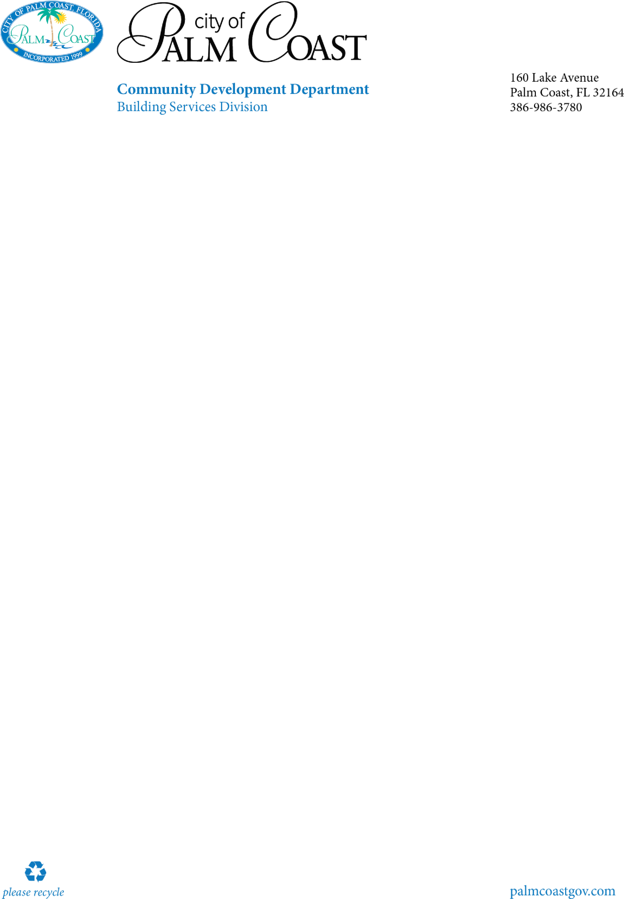

1.

Permit application signed by licensed contractor

2.

Sealed drawings

3.

Site plan

a.

include size of patio with dimensions

b.

include setbacks from property lines

c.

include all existing structures on property

4.

Notice

of commencement

*(*

*certified copy*

*)*

this is required for any improvements to your

property greater than $2,500.The notice of commencement is to be filled out, and

recorded with the Flagler County Clerk’s office in Bunnell. IT is not required at the time of

permit issuance, but will be required prior to any inspections.

Patio/Slab

-

Commer

cial

Checklist

Visit our website for additional information

[c](https://www.palmcoastgov.com/government/building/contractor-permitting)

[https://www.palmcoastgov.com/government/building/contra](https://www.palmcoastgov.com/government/building/contractor-permitting)

[to](https://www.palmcoastgov.com/government/building/contractor-permitting)

[r](https://www.palmcoastgov.com/government/building/contractor-permitting)

[-](https://www.palmcoastgov.com/government/building/contractor-permitting)

[permittin](https://www.palmcoastgov.com/government/building/contractor-permitting)

[g](https://www.palmcoastgov.com/government/building/contractor-permitting)